**List of Issue**

**Login Details**

|  |  |  |  |
| --- | --- | --- | --- |
| **Username** | **Password** | **Login Type** | **UAT URL** |
| sacreator | asdf1234 | Agency | mgeps-uat.philgeps.gov.ph |
| vendor-w1 | dsa@1234 | Merchant | mgeps-uat-pune.etenders.in |

1. Bid event Calendar drawer menu and Bid Event Calendar button showed on dashboard is only visible for Merchant type user.
2. Bid Event calendar UI issue
3. Notification count not showing correct
4. Profile page not showing dynamic data **username: sacreator**

URL: <https://mgeps-uat.philgeps.gov.ph/api/BuyerUsers/userProfile>

Response: {"username":"sacreator","salutation":"Mr","gender":"Male","firstName":"Buyer","middleName":"t","lastName":"Creator","position":"agency creator","email":"saCreator@mailinator.com","organizationName":"001 SOLIGHT AGENCY","landlineNumber":null,"country":"Philippines","region":"NATIONAL CAPITAL REGION (NCR)","state":"CITY OF MANILA","city":"SANTA ANA","streetAddress":"Pureza St. Santa Ana Manila","zipCode":"1020"}

In profile screen only those node and value need to shown but now it’s showing to many other node which not received in the response.

1. Term and condition

URL: <https://mgeps-uat.philgeps.gov.ph/api/BuyerUsers/termsCondition>

Response: {"termsCondition":"Terms and condition for Agency User"}

We have to show the response we getting from above API call. Now it’s showing static data.

1. On detail page while loading data from API show the loading progress bar.
2. 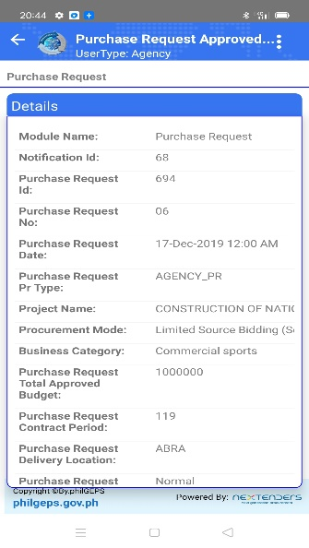View Details was override on footer page. Check the screenshot
3. On setting menu click some additional space showing below the setting name.

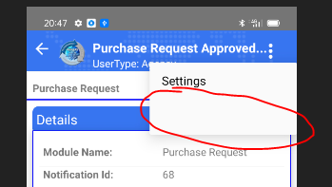

1. Setting page header design is not matching with Dashboard or other design.

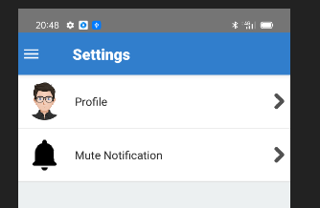

1. If possible then click on mute notification show this details in the popup screen or change the design as show the frame to fill it rich.
2. My Organization Profile page showing loading screen but that should be show in side the content area. Please do this for all other places as well if not considered.

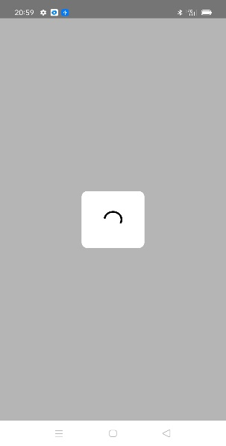

1. My Organization Profile page not showing proper data.

|  |  |
| --- | --- |
| IOS APP | Android APP |
|  |  |

1. Contact us:

Header design not align as per the dashboard.

1. Bid Event Calendar:

Once user cancel the datePicker popup then close the Bid Event Calendar page and navigate to dashboard.